Review 2

Use Case and Sequence Diagram

1. Guest

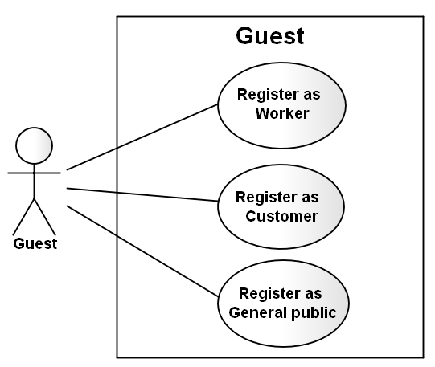

* Regiser as Customer

|  |  |  |
| --- | --- | --- |
| **Author** | Ttrinh Cong Thanh | |
| **Use Case Name** | Register as Customer | |
| **Actors** | Guest | |
| **Description** | Guest wants to register with the website to become a Custommer member. | |
| **Requirements** | Guest provides Guest’s information | |
| **Pre-conditions** |  | |
| **Post-conditions** | Success: Guest creates a Custommer account in this website  Fail: Refill information | |
| **Basic flow** | Actor Actions:  1. Actor clicks ‘Profile’ button in Actor’s Home page menu.  3. Actor Input information and click ‘Save’ button. [Alternative 1] | System Responses:  2. System redirects to Registration page.  4. System redirects to Register page and displays Registration form with the following control :  - ‘UserName’ text field (read only)  - ‘Password’ text field  - ‘Confirm new Password’ text field  - ‘FirstName’ text field  - ‘LastName’ text field  - ‘Gender’ checkbox group  - ‘Birthday’ text field  - ‘Address’ text field  - ‘Phone’ text field  - ‘Email’ text field  - ‘ProofID’ text field  - ‘SecurityQuestion’ text field  - ‘SecurityAnswer’ text field  - ‘Save’ button  - ‘Cancel’ button  6. System checks the information  [Exception 1]  7. System inserts the account into database, show message: ‘Your account has been created!’ and then redirects to Login page. |
| **Alternative flow** | Actor Actions:  [Alternative 1]  1. Actor click ‘Cancel’ button. | System Responses:  2. System returns to Home page. |
| **Exception** | Actor Actions:  [Exception 1]  1. Actor lefts ‘New Password’ text field blank.  2. Actor lefts ‘New Confirm Password’ text field blank.  3. New Password and New Password Confirm don’t match.  4. Actor lefts ‘FirstName’ text field blank.  5. Actor lefts ‘LastName’ text field blank.  6. Actor lefts ‘Birthday’ datebox blank.  7. Input age to ‘Birthday’ datebox less than 16.  8. Actor lefts ‘Address’ text field blank.  9. Actor lefts ‘Phone’ text field blank.  10. Input phone not in numeric or phone length not in range 8 – 15 character.  11. Actor lefts ‘Email’ text field blank or input an invalid email address.  12. Actor lefts ‘ProofID’ textfield blank  13. Input proofID not in numeric or phone lenhth not in range 9 – 12 character. | System Responses:  System displays message to Actor :  - ‘Password cannot be blank’’.  - ‘Confirm Password can’t be blank’.  - ‘Confirm password not match Password.’  - ‘Name cannot be blank’.  - ‘Birthday is invalid’.  - ‘Age must over 16’.  - ‘Address cannot be blank’.  - ‘Phone is invalid’.  - ‘The phone number should be numeric only and must be between 8 and 15 digits’.  - ‘Email is invalid’.  - ‘The proofID number should be numeric only and must be between 9 and 12 digits’. |

1. 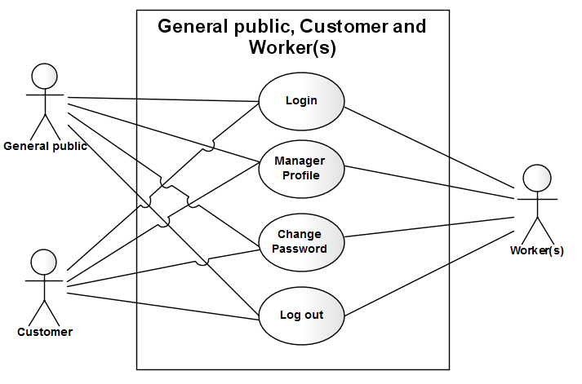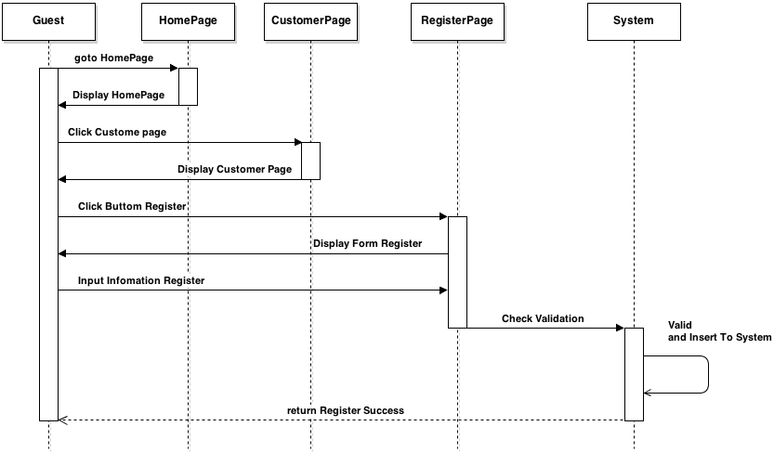General public , Custommer, and Woker

Login

|  |  |  |
| --- | --- | --- |
| **Author** | Trinh Cong Thanh | |
| **Use Case Name** | Login | |
| **Actors** | Custommer or General public or Worker | |
| **Description** | Custommer or General public or Worker wants to login to website as a Custommer or General public or Worker member. | |
| **Requirements** | Actor provides username and password | |
| **Pre-conditions** |  | |
| **Post-conditions** | Success: User logged in to website.  Fail: Refill information | |
| **Basic flow** | Actor Actions:  1. Actor go to Home page of website.  3. Actor inputs UserName and Password, then click the Login button. | System Responses:  2. System redirects to Home page and displays Login form on the left with the following control:  - ‘UserName’ text field  - ‘Password’ text field  - ‘Go’ button  4. System checks the information  [Exception 1]  5. System redirects to Actor’s Home page. |
| **Alternative flow** | Actor Actions:  [Alternative 2]  1. Actor click ‘OK’ button, inputs UserName and Password, then click the Login button.  [Alternative 1]  1. Actor click ‘Back to Home’ button. | System Responses:  2. System checks the information  [Exception 1]  3. System redirects to Actor’s Home page.  2. System returns to Home page. |
| **Exception** | Actor Actions:  [Exception 1]  1. Actor input invalid username and password. | System Responses:  - System redirect to Login page with the following controls:  - ‘UserName’ text field  - ‘Password’ text field  - ‘Login’ button.  - ‘Back to Home’ button.  System show a message box: “Invalid Username and password”.[Alternative 2] |

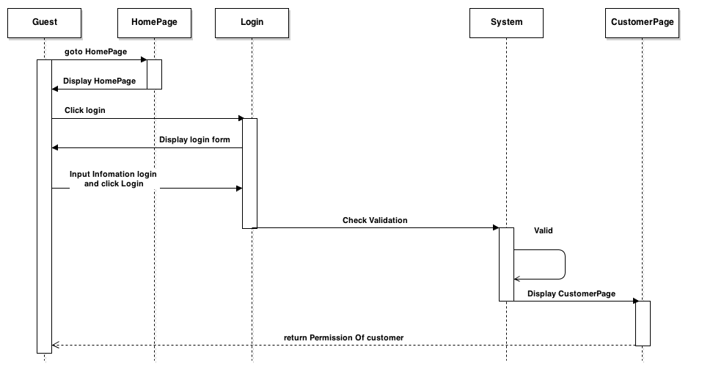

Manage profile and change password

|  |  |  |
| --- | --- | --- |
| **Author** | Trinh Cong Thanh | |
| **Use Case Name** | Update Profile | |
| **Actors** | Custommer or General public or Worker | |
| **Description** | Custommer or General public or Worker wants to Update his/her profile’s information. | |
| **Requirements** | Actor provides profile information | |
| **Pre-conditions** | Actor has logged in. | |
| **Post-conditions** | Success: Profile’s information of this user has been updated.  Fail: Refill information | |
| **Basic flow** | Actor Actions:  1. Actor clicks ‘Profile’ button in Actor’s Home page menu.  3. Actor Input updates information and click ‘Save’ button. [Alternative 1] | System Responses:  2. System redirects to Update Profile page and displays Update Profile form with the following control :  ‘UserName’ text field (read only)  - ‘Old Password’ text field  - ‘New Password’ text field  - ‘Confirm new Password’ text field  - ‘FirstName’ text field  - ‘LastName’ text field  - ‘Gender’ checkbox group  - ‘Birthday’ text field  - ‘Address’ text field  - ‘Phone’ text field  - ‘Email’ text field  - ‘ProofID’ text field  - ‘SecurityQuestion’ text field  - ‘SecurityAnswer’ text field  - ‘Save’ button  - ‘Cancel’ button  4. System checks the information  [Exception 1]  5. System update the account into database and then redirects to Actor Home page. |
| **Alternative flow** | Actor Actions:  [Alternative 1]  1. Actor click ‘Back to Home’ button. | System Responses:  2. System returns to Home page. |
| **Exception** | Actor Actions:  [Exception 1]  1. Actor lefts ‘New Password’ text field blank.  2. Actor lefts ‘New Confirm Password’ text field blank.  3. New Password and New Password Confirm don’t match.  4. Actor lefts ‘FirstName’ text field blank.  5. Actor lefts ‘LastName’ text field blank.  6. Actor lefts ‘Birthday’ datebox blank.  7. Input age to ‘Birthday’ datebox less than 16.  8. Actor lefts ‘Address’ text field blank.  9. Actor lefts ‘Phone’ text field blank.  10. Input phone not in numeric or phone length not in range 8 – 15 character.  11. Actor lefts ‘Email’ text field blank or input an invalid email address.  12. Actor lefts ‘ProofID’ textfield blank  13. Input proofID not in numeric or phone lenhth not in range 9 – 12 character. | System Responses:  System displays message to Actor :  - ‘Password cannot be blank’’.  - ‘Confirm Password can’t be blank’.  - ‘Confirm password not match Password.’  - ‘Name cannot be blank’.  - ‘Birthday is invalid’.  - ‘Age must over 16’.  - ‘Address cannot be blank’.  - ‘Phone is invalid’.  - ‘The phone number should be numeric only and must be between 8 and 15 digits’.  - ‘Email is invalid’.  - ‘The proofID number should be numeric only and must be between 9 and 12 digits’. |

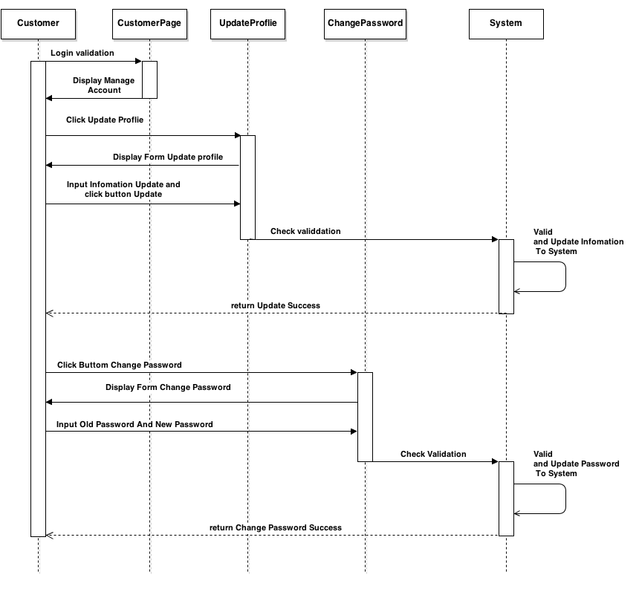

Logout

|  |  |  |
| --- | --- | --- |
| **Author** | Trinh Cong Thanh | |
| **Use Case Name** | Login | |
| **Actors** | Custommer or General public or Worker | |
| **Description** | Custommer or General public or Worker wants to log out of the System. | |
| **Requirements** |  | |
| **Pre-conditions** | Actor has logged in. | |
| **Post-conditions** | Success: Actor Logged out. | |
| **Basic flow** | Actor Actions:  1. Actor clicks ‘Log out’ button on the Actor’s Home menu. | System Responses:  2. System redirect to Logout page, remove session, and then redirect to Login page. |
| **Alternative flow** |  |  |
| **Exception** |  |  |

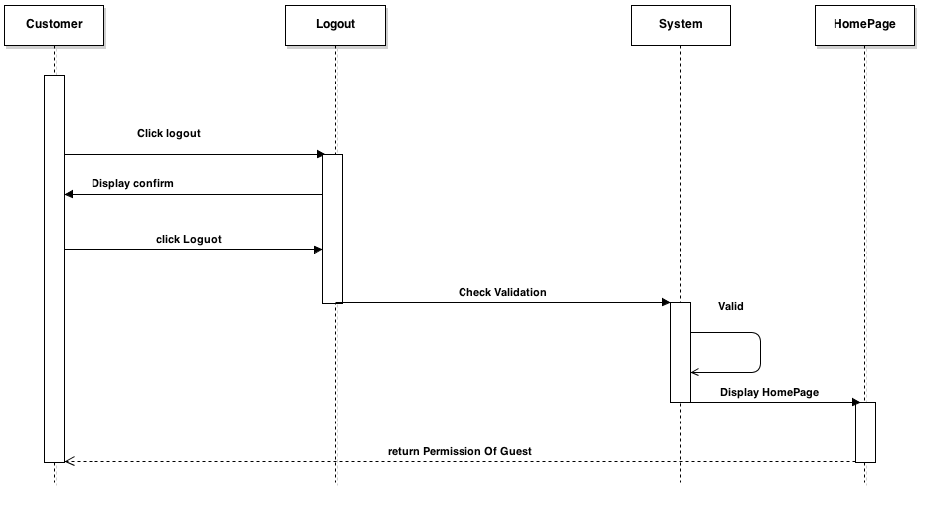

General public and CustommerFeedback

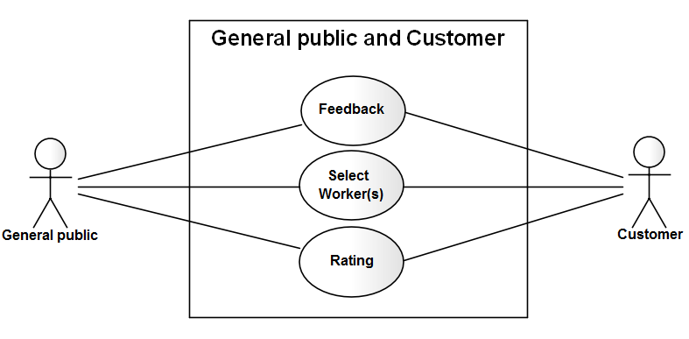

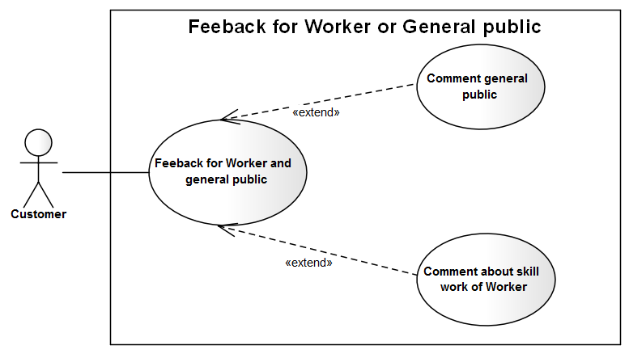

|  |  |  |
| --- | --- | --- |
| **Author** | Trinh Cong Thanh | |
| **Use Case Name** | Feedback | |
| **Actors** | Custommer or General public | |
| **Description** | Custommer or General public feedback | |
| **Requirements** |  | |
| **Pre-conditions** | Actor has logged in. | |
| **Post-conditions** |  | |
| **Basic flow** | Actor Actions:  1. Actor clicks ‘Feedback’ button on the Actor Home page menu.  3. Actor inputs UserName Need feedback, Content Comment, and click ‘Feedback’ button. [Alternative 1] | System Responses:  2. System redirect to FeedbackPage and show Feedback form with the following controls:  - ‘FeedbackTo’ text field.  - ‘Content’text field.  - ‘Feedback’ button.  - ‘Back to Home’ button.  4. System checks the information  [Exception 1].  5. System Insert information Feedback to system. |
| **Alternative flow** | Actor Actions:  [Alternative 1]  1. Actor click ‘Back to Home’ button. | System Responses:  2. System returns to Actor Home page. |
| **Exception** | [Exception 1]  1. UserName is invalid, username is not null  2. Content Comment not null  3. Input Content Comment more than 20 character and less than 500 character | System Responses:  - System shows the message: ‘Invalid Username’,’username is not null’.- System shows the message:’comtent is not null, more than 20 character and less than 500 character’. |

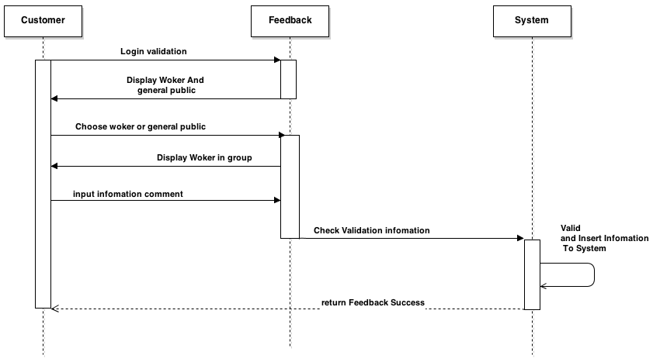

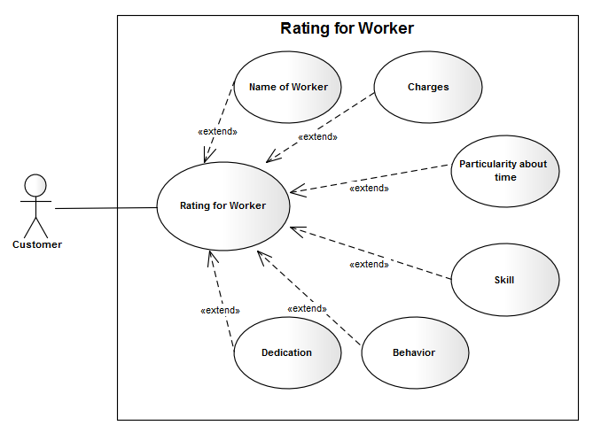Ratting

|  |  |  |
| --- | --- | --- |
| **Author** | Trinh Cong Thanh | |
| **Use Case Name** | Rating Woker | |
| **Actors** | Custommer | |
| **Description** | Custommer or General public ratting worker | |
| **Requirements** |  | |
| **Pre-conditions** | Actor has logged in. | |
| **Post-conditions** |  | |
| **Basic flow** | Actor Actions:  1. Actor clicks ‘select Woker’ button on the Actor Home page menu.  3.Actor Choose worker and click buttom ratting to group  4.Actor input information ratting and click ‘Submit’ button [Alternative 1] | System Responses:  2. System redirect to Select Worker and show list Woker  4. Form rating worker display with the following controls:  - Worker Skill  - Charges  - Particularity about time,  - dedication  - behavior  - habits  - ‘Submit’ buttom  - ‘Cancel’ button.  5. System checks the information  6. System Update rangting to system. |
| **Alternative flow** | Actor Actions:  [Alternative 1]  1. Actor click ‘Cancel’ button. | System Responses:  2. System returns to Actor Home page. |
| **Exception** |  |  |

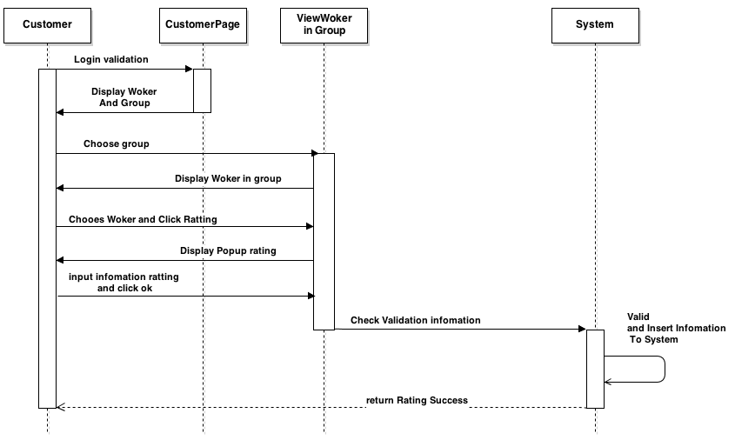

Custoomer

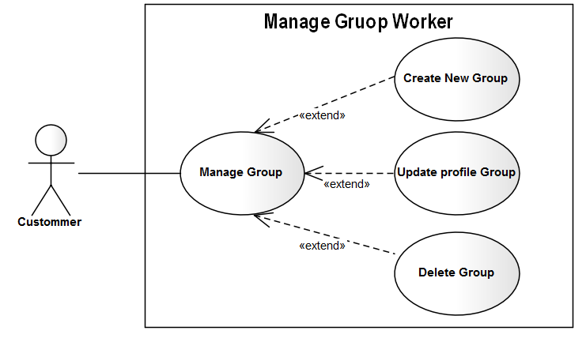Manage Gruop Worker

|  |  |  |
| --- | --- | --- |
| **Author** | Trinh Cong Thanh | |
| **Use Case Name** | Manage Group Woker | |
| **Actors** | Custommer | |
| **Description** | Custommer | |
| **Requirements** |  | |
| **Pre-conditions** | Actor has logged in. | |
| **Post-conditions** |  | |
| **Basic flow** | Actor Actions:  1. Actor clicks ‘manage Group’ button on the Actor Home page menu.  3. Actor clicks ‘Create Group’ button on the Actor Home page menu  6. ActorInput information and click ‘Create Group’ button [Alternative 1]  7. Actor choose Group and click edit on Actor homepage  9. Actor input information and click ‘Update’ button [Alternative 1]  11. Actor choose Group and click Delete on Actor homepage  13.Action click ‘Delete’ botton [Alternative 1] | System Responses:  2.System redirect to GroupWorker Page and showlist Group of worker  4. Form Create new Group Display with the following controls  - ‘Group Name’ text field.  - ‘Descripttion’text field.  - ‘Create Group’ button.  - ‘Cancel’ button.  6. System Insert information to system  8. Form Update Group Display with the following controls :  ‘Group Name’ text field.  - ‘Descripttion’text field.  - ‘Update’button.  - ‘Cancel’ button.  10. System Update information to system  12. Cofirm popup delete group display  - ‘Delete’ button  -‘Cancel’ button  [Exception 1].  14. System Delete information to system. |
| **Alternative flow** | Actor Actions:  [Alternative 1]  1. Actor click ‘Cancel’ button. | System Responses:  2. System returns to Actor Home page. |
| **Exception** | [Exception 1]  1. Group name is not null,Descripttion is not null  2. Input GroupName more than 1 character and less than 250 character  3. Input Descripttion more than 10 character and less than 250 character | System Responses:  - System shows the message: ‘Group name’,’ Descripttion” is not null.  - System shows the message: GroupName more than 1 character and less than 250 character’.  - System shows the message: Descripttion more than 10 character and less than 250 character’ |

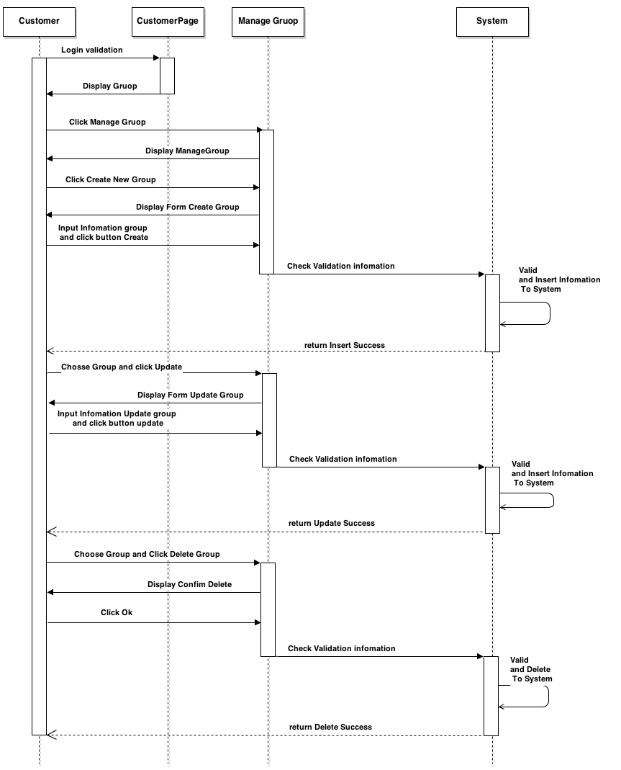

Manage worker to group

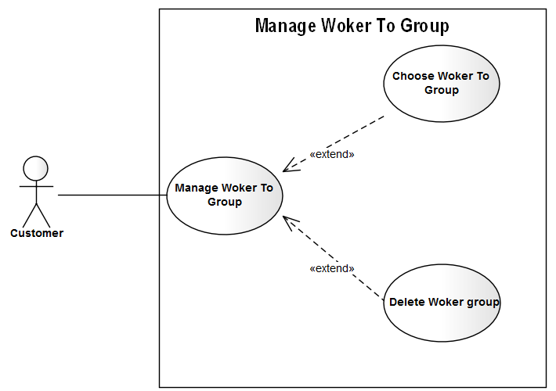

|  |  |  |
| --- | --- | --- |
| **Author** | Trinh Cong Thanh | |
| **Use Case Name** | Manage Woker in Group | |
| **Actors** | Custommer | |
| **Description** | Custommer | |
| **Requirements** |  | |
| **Pre-conditions** | Actor has logged in. | |
| **Post-conditions** |  | |
| **Basic flow** | Actor Actions:  1. Actor clicks ‘manage Worker in group” button on the Actor Home page menu.  3 Actor choose Woker click button add to group on the table list Woker  5 . Actor Click ok [Alternative 1]  7. Actor view Group  9.Choose Worker in group and click ‘Delete’ button  11. Click ‘submit’ button  [Alternative 1] | System Responses:  2.System redirect to Worker to groupPage and showlist Worker to group  4. Confirm Add Woker is choose on group popup Show with  - ‘Submit’ button  - ‘Cancel’ button  6. System Insert information to system  8.System redirect to showlist Worker in group  10. popup Confirm Delete Worker in group with  -‘Submit’ button.  -‘Cancel’ button.  [Exception 1].  12. System Delete information to system. |
| **Alternative flow** | Actor Actions:  [Alternative 1]  1. Actor click ‘Cencel’ button. | System Responses:  2. System returns to Actor Home page. |
| **Exception** |  |  |

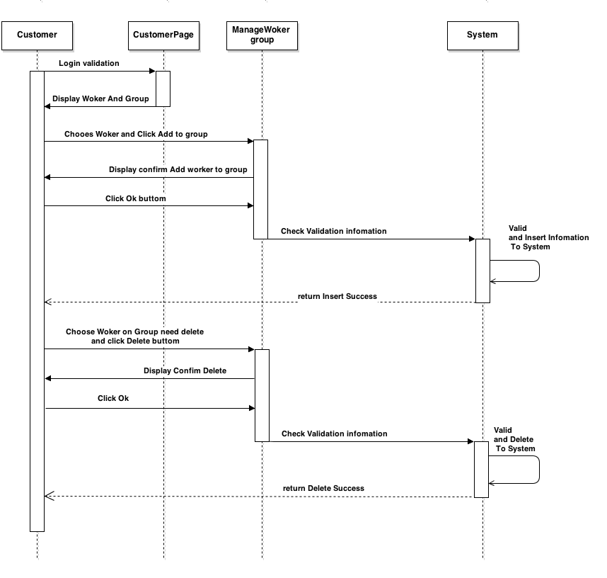

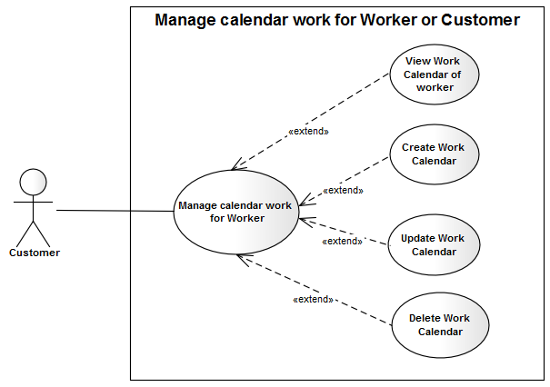Work Calendar

|  |  |  |
| --- | --- | --- |
| **Author** | Trinh Cong Thanh | |
| **Use Case Name** | Work Calendar | |
| **Actors** | Custommer | |
| **Description** | Custommer | |
| **Requirements** |  | |
| **Pre-conditions** | Actor has logged in. | |
| **Post-conditions** |  | |
| **Basic flow** | Actor Actions:  1. Actor clicks ‘manage Work Calendar  3 .Actor choose Woker click ‘View Work calendar’p on the table list Woker  5. Actor click ‘Close’ button  6 . Actor choose woker and click ‘create Work calendar’ button  8. Actor Click Submit [Alternative 1]  10.Actor choose woker and click ‘Update Work calendar’ button  12. Actor Click Submit [Alternative 1]  14.Choose Worker in group and click ‘Delete Calendar’ button  16. Actor Click Submit [Alternative 1] | System Responses:  2.System showlist Worker on group  3.System Show information Work calendar of worker with  - ‘Close’ button  5. System Close view Work calendar  7. Form Create Work Calendar Show with  - droplist From Time All Of Week  - droplist To Time All Of Week  - ‘Submit’ button  - ‘Cancel’ button  [Exception 1].  9. System Insert information to system  11. Form Create Work Calendar Show with  -‘StartDate’ text field  -‘EndDate’ text field  - droplist Srart Time All Of Week  - droplist End Time All Of Week  - ‘Submit’ button  - ‘Cancel’ button  [Exception 1].  13. System Update information to system  15. pupup Confirm delete Show With  - ‘Submit’ button  - ‘Cancel’ button  13. System Delete information to system |
| **Alternative flow** | Actor Actions:  [Alternative 1]  1. Actor click ‘Back to Home’ button. | System Responses:  2. System returns to Actor Home page. |
| **Exception** | [Exception 1].  1.‘StartDate’ text field is not null  2.‘EndDate’ text field is not null  3.StartDate more less than EndDate  4.Start Time All Of Week more less than End Time All Of Week | [Exception 1].  1.System shows the message : Stardate not null  1.System shows the message : Enddate not null  3.System shows the message : StartDate more less than EndDate  4.Start Time All Of Week more less than End Time All Of Week |

